The Formal Elements in Art
The Formal Elements are the parts used to make a piece of artwork. The art elements are line, shape, form, tone, texture, pattern, colour and composition. They are often used together, and how they are organised in a piece of art determines what the finished piece will look like.

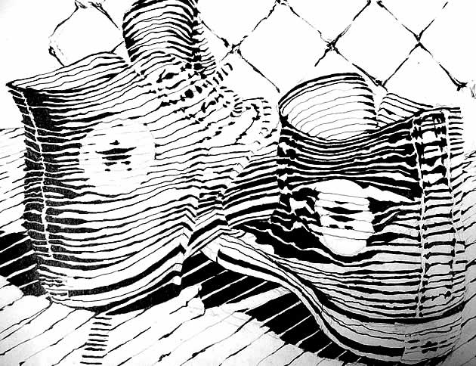
Line
Line is the path left by a moving point. For example, a pencil or a brush dipped in paint. A line can take many forms. It can be horizontal, diagonal or curved. It can also change over its length, starting off curved and ending up horizontal, for example.
Line can be used to show many different qualities, such as:
- contours – showing the shape and form of something
- feelings or expressions – a short, hard line gives a different feeling to a more flowing one
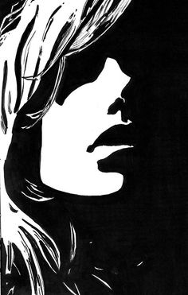
- movements- Rhythms and patterns of a line.

Shape
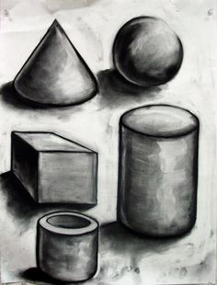
A shape is an area enclosed by a line. It could be just an outline or it could be shaded in. Shapes can be either geometric, like a circle, square or triangle, or irregular. When drawing shapes, you must consider the size and position as well as the shape of the area around it. The shapes created in the spaces between shapes are referred to as negative space.

Form
Form is a three dimensional shape, such as a cube, sphere or cone.
Sculpture and 3D design are about creating forms. In 2D artworks, tone and perspective can be used to create an illusion of form.

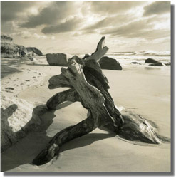
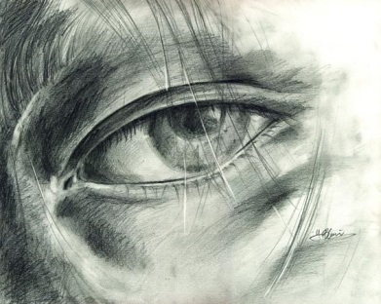
Tone
This refers to the lightness or darkness of something. This could be a shade or how dark or light a colour appears.
Tones are created by the way light falls on a 3D object. The parts of the object on which the light is strongest are called highlights and the darker areas are called shadows. There will a range of tones in between the highlights and shadows.

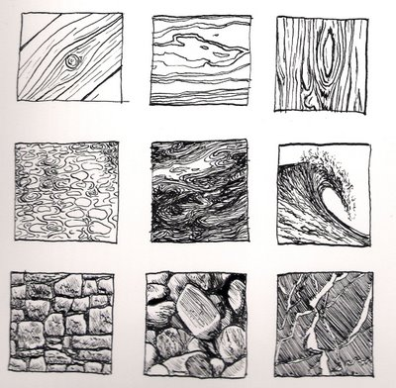
Texture
This is to do with the surface quality of something, the way something feels or looks like it feels. There are two types of texture: actual texture and visual texture.
Actual texture really exists, so you can feel it or touch it. You can create actual texture in an artwork by changing the surface, such as sticking different fabrics onto a canvas. Combining different material techniques can create interesting textures.
Visual texture is created using marks to represent actual texture. It gives the illusion of a texture or surface but if you touched it, it would be smooth. You can create visual texture by using different lines, shapes, colours or tones. Think about how different marks can be used to show texture.
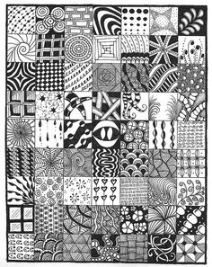
Pattern
A design that is created by repeating lines, shapes, tones or colours. The design used to create a pattern is often referred to as a motif. Motifs can be simple shapes or complex arrangements.
Patterns can be man-made, like a design on fabric, or natural, such as the markings on animal fur.

Colour
Red, yellow and blue are primary colours, which means they can’t be mixed using any other colours. In theory, all other colours can be mixed from these three colours.
Two primary colours mixed together make a secondary colour.

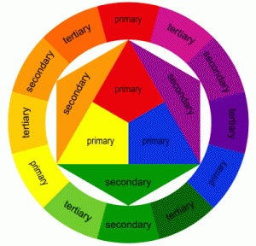
Colour wheel
- Colours that are next to each other on the colour wheel are called harmonious.
- Complementary colours are colours that are opposite each other on the colour wheel. When complementary colours are used together they create contrast. Adding a colour’s complimentary colour will usually make a darker shade. This is often preferable to adding black.
- Warm colours are colours on the red side of the wheel. These are red and include orange, yellow, browns and tans.
- Cool colours are colours on the blue side of the wheel. These are blue and include green, violet and most greys.
- Black, white and grey are called neutral colours.

Monochromatic
Monochrome means one colour. Artwork can be created that explores the tone and intensity of a selected colour.
You can change the tone of a colour by adding its complementary colour or by adding black or white to it. Adding white to a colour creates a tint, and adding black creates a tone. You can also alter the tone of a colour with saturation techniques. This means adding either more paint or more water. The more water that is added the lighter the tone and the more paint the darker.

Limited colour
You can select a limited number of colours and use these to represent different tones. For example, you could pick two complimentary colours, or you could use only the three primary colours. This can create a striking image.

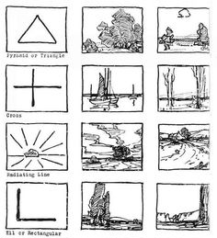
Composition
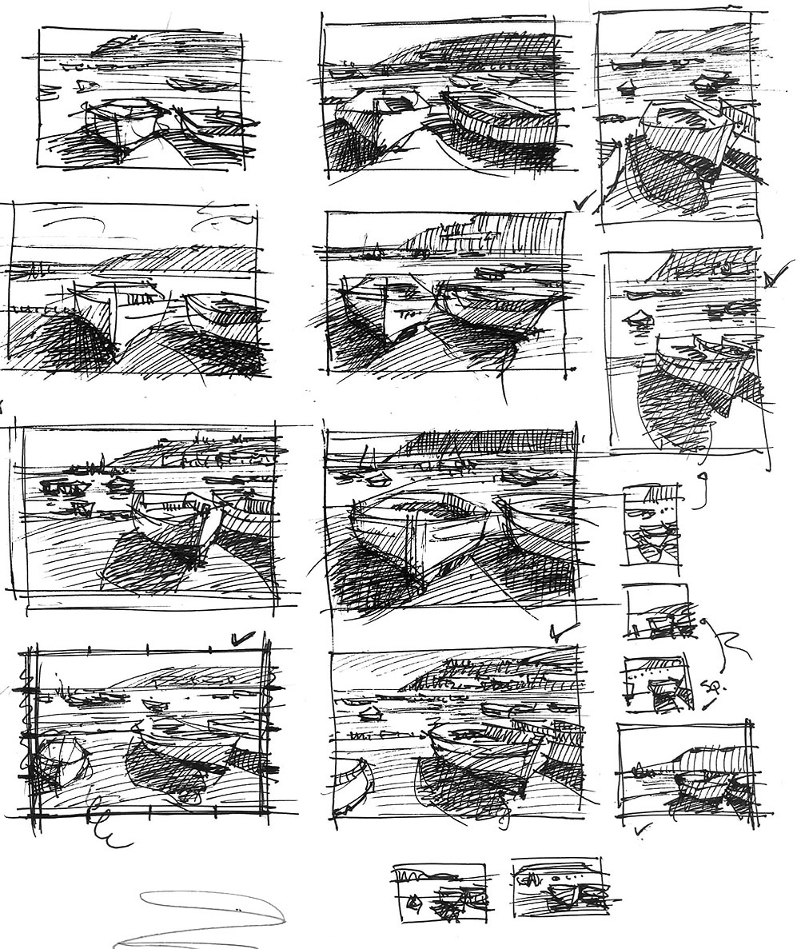
The term composition means ‘putting together,’ and can apply to any work of art, from music to writing to photography, that is arranged or put together using conscious thought. In the visual arts, composition is often used interchangeably with various terms such as design, form, visual ordering, or formal structure, depending on the context.
There are numerous approaches or “compositional techniques” to achieving a sense of unity within an artwork, depending on the goals of the artist. For example, a work of art is said to be aesthetically pleasing to the eye if the elements within the work are arranged in a balanced compositional way. However, there are artists such as Salvador Dali whose sole aim is to disrupt traditional composition and challenge the viewer to rethink balance and design elements within art works.

