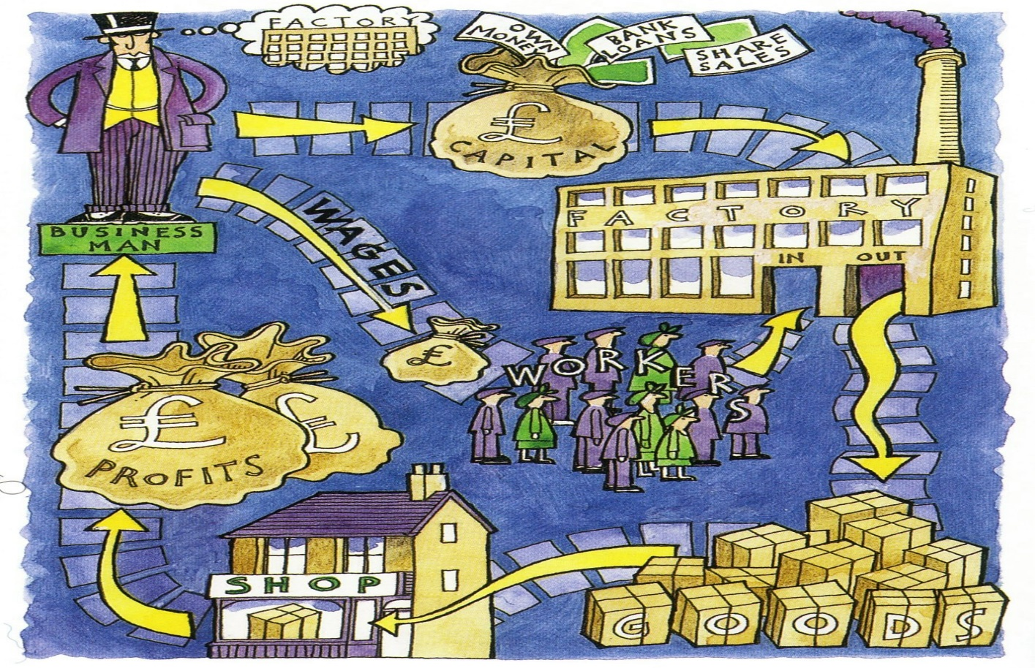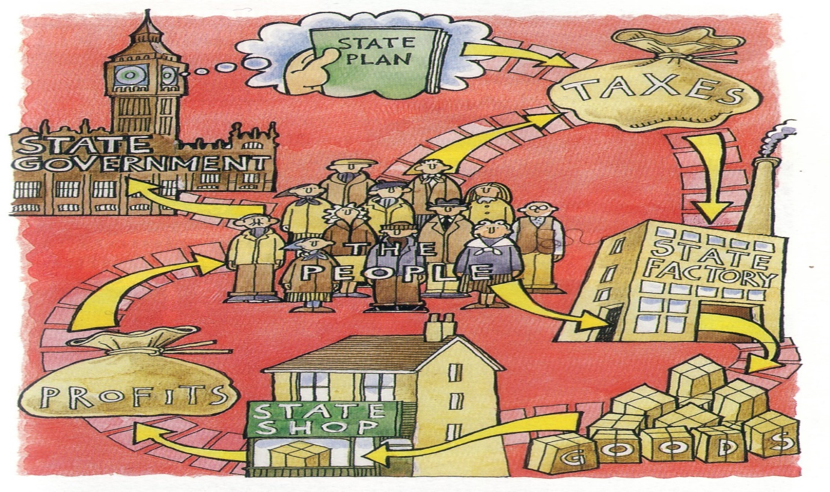

Capitalism…..

Communism…..

Soviet Union (USSR)

US and Britain